C PROGRAMMING
NAME : YOKITHA S
ROLL NO: 241801327
WEEK 10
TOPIC : CHARACTER ARRAYS

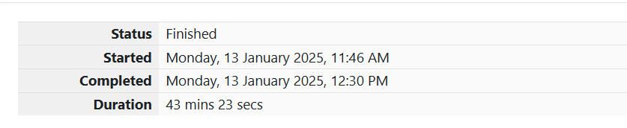

1. Problem Statement: Strings
You are given two strings a and b, separated by a new line. Each string will consist of lower-case Latin characters ('a'-'z').
Input Format
- Two strings a and b, each on a separate line.
Output Format
- In the first line, print two space-separated integers representing the length of a and b respectively.
- In the second line, print the string produced by concatenating a and b (a + b).
- In the third line, print two strings separated by a space: a' and b'. Here, a' and b' are the same as a and b, respectively, except that their first characters are swapped.
Sample Input
Copy code
abcd
ef
Sample Output
ruby
Copy code
4 2
abcdef
ebcd af

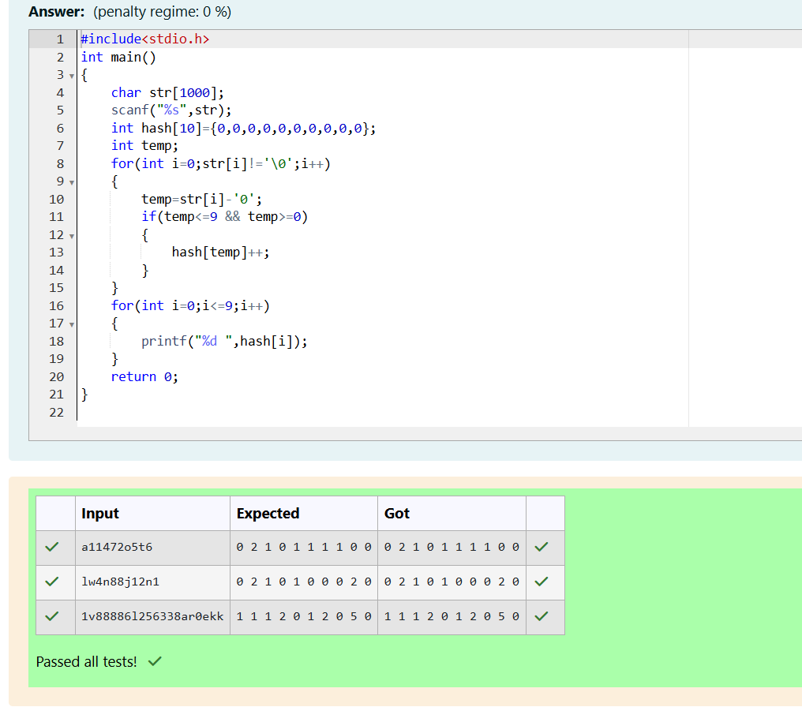

2. Problem Statement: Printing Tokens
Given a sentence s, print each word of the sentence on a new line.
Input Format
- A single line containing the sentence s.
Constraints
- 1≤len(s)≤10001 \leq \text{len}(s) \leq 10001≤len(s)≤1000
Output Format
- Print each word of the sentence on a new line.
Sample Input
csharp
Copy code
This is C
Sample Output
csharp
Copy code
This
is
C
Hint
Iterate through the input and print each character unless a space is encountered. When a space is encountered, move to a new line.

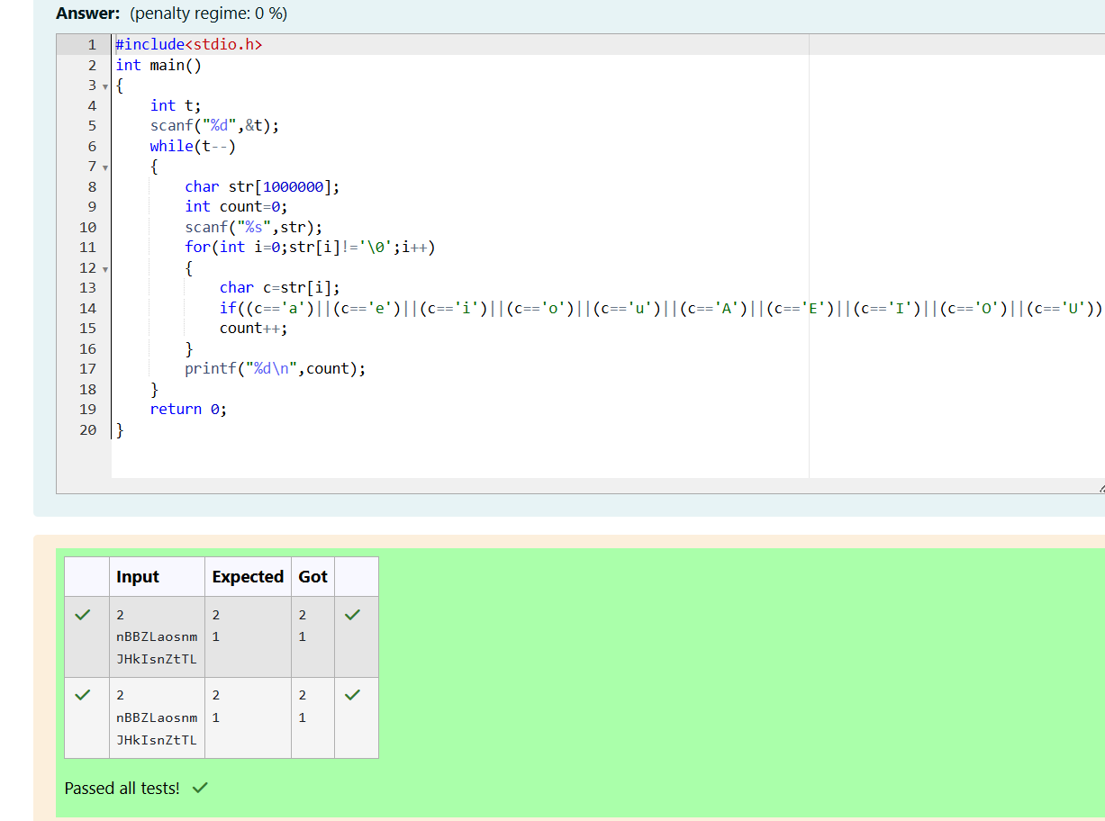3.Problem Statement: Digit Frequency
Given a string s, consisting of alphabets and digits, find the frequency of each digit in the given string.
Input Format
- The first line contains a string num, which is the given number.
Constraints
- 1≤len(num)≤10001 \leq \text{len}(num) \leq 10001≤len(num)≤1000
- All elements of num are made of English alphabets and digits.
Output Format
- Print ten space-separated integers in a single line denoting the frequency of each digit from 0 to 9.
Sample Input
Copy code
a11472o5t6
Sample Output
Copy code
0 2 1 0 1 1 1 1 0 0

